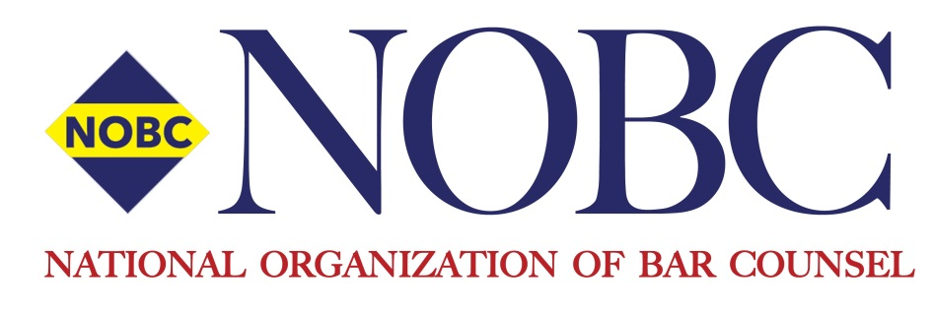
NOBC 2014 Election of Officers and Directors
August 8, 2014
Boston, MA
NOBC AT-LARGE DIRECTOR ELECTION PROXY

I ___________________________________ a member of the National
(NOBC member’s name)

Organization of Bar Counsel from ________ affirm that I am or will be
(jurisdiction)

in attendance at the NOBC Annual Meeting held in Boston, MA from

August 6 through 9, 2014, but that I will not be present during the

business meeting at which the NOBC Election of Officers and Directors

will take place. Therefore, I give my proxy for purposes of voting for

a candidate for NOBC At-Large Director at the August 8, 2014 election

to NOBC member __________________________________________ (NOBC member’s name to whom proxy is given)

from ________.
(jurisdiction)

_____________________________________ ________________
Signature Date
PLEASE NOTE: This proxy must be signed by the member granting the proxy and lodged with the NOBC Secretary, preferably prior to the start of the NOBC business meeting at 9:00 a.m. edt on August 8, 2014, but in any event no later than the call of the vote.

